Q.2

Ans:

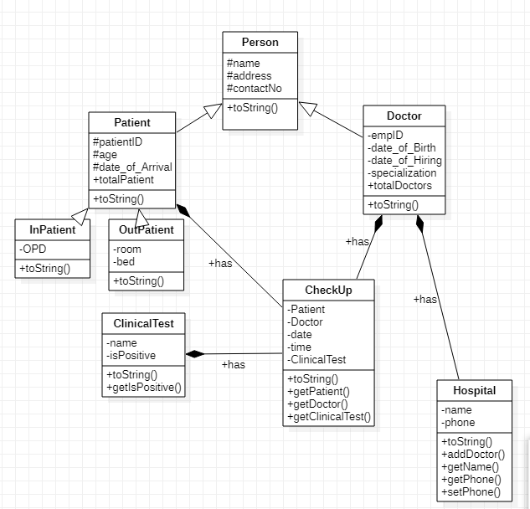

Q.10 What type should you use for the doctors’ collection?

Ans: I used type Doctor for the doctor’s collection.

* 1. Q.10(d) How can use make use of the toString() method of Doctor when writing the toString() of Hospital ?
  2. Ans: I simply call toString() method with Arraylist Doctor object which is doctors like doctors.toString(). This doctors.toString() will return me collection of doctors separated by comma.